**INDEX**

|  |  |  |
| --- | --- | --- |
| **Sr. No.** | **Title** | **Page No.** |
| 1 | Problem statement | 3 |
| 2 | Software/Hardware Used | 3-8 |
| 3 | Circuit Diagram | 9-10 |
| 4 | Program for Arduino-based optical proximity sensor using 2 IR LEDs | 11-12 |
| 5 | Result | 11-15 |
| 6 | Conclusion | 16 |
| 7 | Project Outcome | 16 |

**Problem Statement**

To design Proximity Sensor using 2 IR Led’s Interfacing Arduino Uno

**Software/Hardware Used**

**Hardware components:**

* Arduino Uno
* 2 IR Sensor (HW-201) module
* 2 LED
* 2 resistor
* Breadboard
* Jumper wires

Description about components-

1. **IR Sensor-** IR sensors or Infra-Red Sensors are used in obstacle detection and motion sensing. IR transmitter emits infrared rays and when an obstacle comes in between its path or passes by the infrared rays are reflected back on the sensor and the IR receiver gets activated sensing the presence of an obstacle or a motion happening in its area of use.

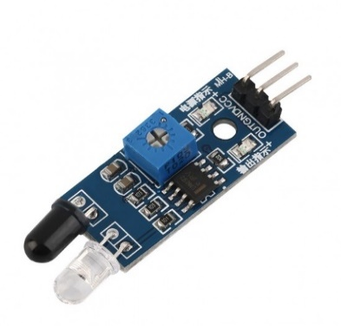

Features/Datasheet of IR Sensor:

* 5VDC operating voltage.
* I/O pins are 5V and 3.3V compliant.
* Range: Up to 20cm.
* Adjustable Sensing range.
* Built-in Ambient Light Sensor.
* 20mA supply current.
* Mounting hole.
* Size: 50 x 20 x 10 mm (L x B x H)
* Hole size: φ2.5mm

Proximity sensors are used to detect something approaching near. These sensors are useful in many applications like collision avoidance, obstacle detection, path following, touchless sensing, motion detection, and object detection. There are different types of proximity sensors like optical, ultrasonic, capacitive, inductive, and magnetic. The capacitive, inductive, and magnetic proximity sensors are used in specific electronic applications. The optical and ultrasonic proximity sensors have much general use and are quite common among electronics. These sensors come in a wide range according to their technology and distance of sensing. The most simple kind of proximity sensor is the optical one. These proximity sensors are designed using active infrared sensors, consisting of a pair of IR source and an IR detector. The IR source can be either IR LED (Infrared Light Emitting Diode) or IR Laser Diode. The IR LED or IR Laser Diode transmits infrared light. This light is reflected by any object on which it falls. IR photodiodes that operate as IR detectors are placed in the sensor to capture the reflected IR radiations in a predefined range of distance and angle. Closer is the reflecting object; higher is the intensity of infrared radiation reflected, and lower IR photodiode resistance drops. As a result, IR photodiode passes through greater voltage than when there are no incident IR radiation.

](https://www.engineersgarage.com/wp-content/uploads/2020/12/P05-01.png)

Working of active IR sensors- In this project, a proximity sensor built using 2 LED’s and 2 IR Sensors is used. The proximity sensors built using IR LEDs can sense objects at a short range of few centimeters. The sensor is interfaced with Arduino for application demonstration. In this project, we simply fast blink an LED as the sensor detects a near approaching object. The fast blinking of LED in this project indicates the possibility of a collision with the near approaching object. It gives a visual indication to the user to urge her to act quickly, avoiding a collision.

1. **Blinking Two LED**- The concept of blinking two LED's is similar to the blinking of a single LED. As we know, we can use the resistance of any value, so let's take the resistors of 470 Ohms. The resistors reduce the amount of current reaching the LED, which saves the LED from being burnt. We can also use other resistors depending on the circuit limit and requirements.

Structure of two LED's**-** The structure of red and green [LED](https://www.javatpoint.com/led-full-form) is shown below:

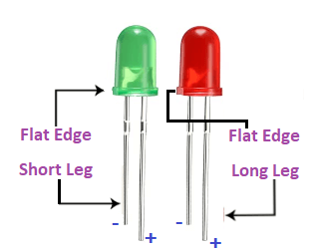

The long terminal is called Anode (positive charged), and the short terminal is called Cathode (negative charged).

**Structure of the project**

The structure will represent the pinout diagram of the project. It is shown below:

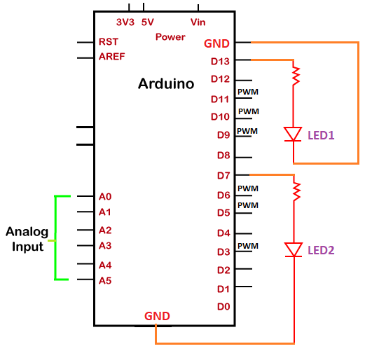

**How the circuit works**- The IR LED is connected in forward bias in the sensor module. As 5V DC powers the module, the IR LED starts emitting IR radiations. An IR photodiode is placed parallel to the IR LED to detect the reflected radiations. The photodiode is connected in a voltage divider network, whose output goes to the inverting input of LM393 comparator IC. The non-inverting input of the same comparator is connected to a pot for adjustment of the reference voltage. The output of the comparator is taken as the output of the module. When the IR detector receives reflected radiations, its resistance drops. As a result, a voltage higher than the reference voltage is applied at the comparator’s inverting input, and the comparator output turns to LOW.

**How the code works** The Arduino sketch begins with pin assignment to the IR sensor and indicator LED. In the setup() function, the pin connecting the IR sensor is set to digital input, and the pin connecting indicator LED is set as output. A function blink indicator is defined to blink the LED at an interval of 200 milliseconds. In the loop function, if a LOW is detected at the IR pin, blink indicator function is called. Otherwise, the LED pin is set to LOW, keeping the LED off.

**Circuit Diagram:**

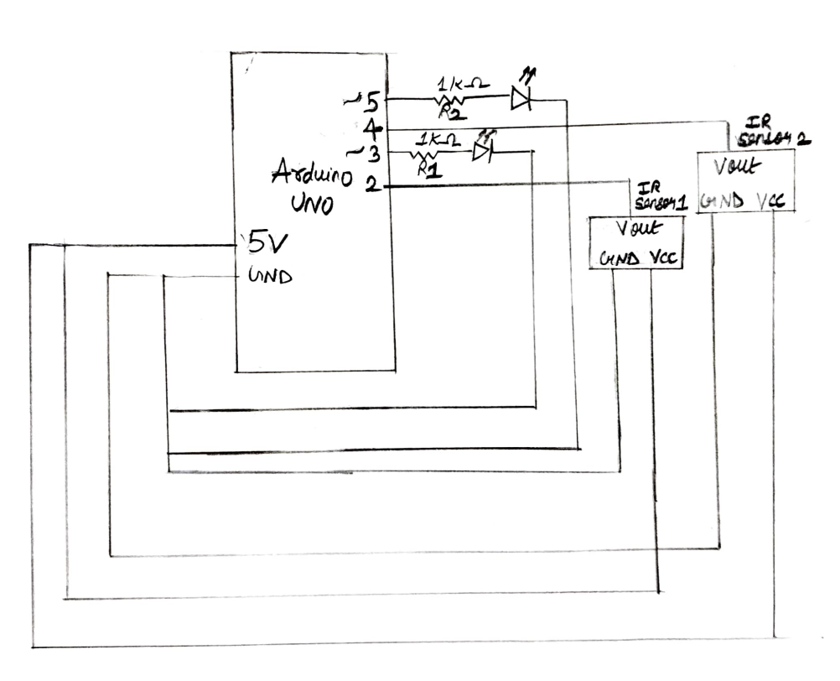

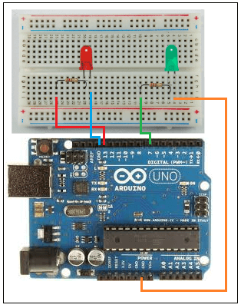

**Fig1**- Interfacing LED with Arduino

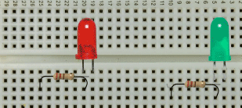

**Fig2-** Connection of 2 LED’S

**Program for Blinking Led using 2 IR sensor to Arduino**

#include<stdio.h>

#include<stdlib.h>

unsigned int IRpin1 = 2;

unsigned int IRpin2 = 4;

unsigned int Indicatorpin1= 3;

unsigned int Indicatorpin2= 5;

void blink_indicator1(){

digitalWrite(Indicatorpin1, HIGH);

delay(200);

digitalWrite(Indicatorpin1, LOW);

delay(200);

}

void blink_indicator2(){

digitalWrite(Indicatorpin2, HIGH);

delay(200);

digitalWrite(Indicatorpin2, LOW);

delay(200);

}

void setup() {

pinMode(IRpin1, INPUT_PULLUP);

pinMode(IRpin2, INPUT_PULLUP);

pinMode(Indicatorpin1, OUTPUT);

pinMode(Indicatorpin2, OUTPUT);

}

void loop()

{

if(digitalRead(IRpin1)==LOW)

{

blink_indicator1();

}

else if(digitalRead(IRpin2)==LOW);

{

blink_indicator2();

}

///else if(digitalRead(IRpin2)==HIGH);

///{

/// blink_indicator2();

///}

}

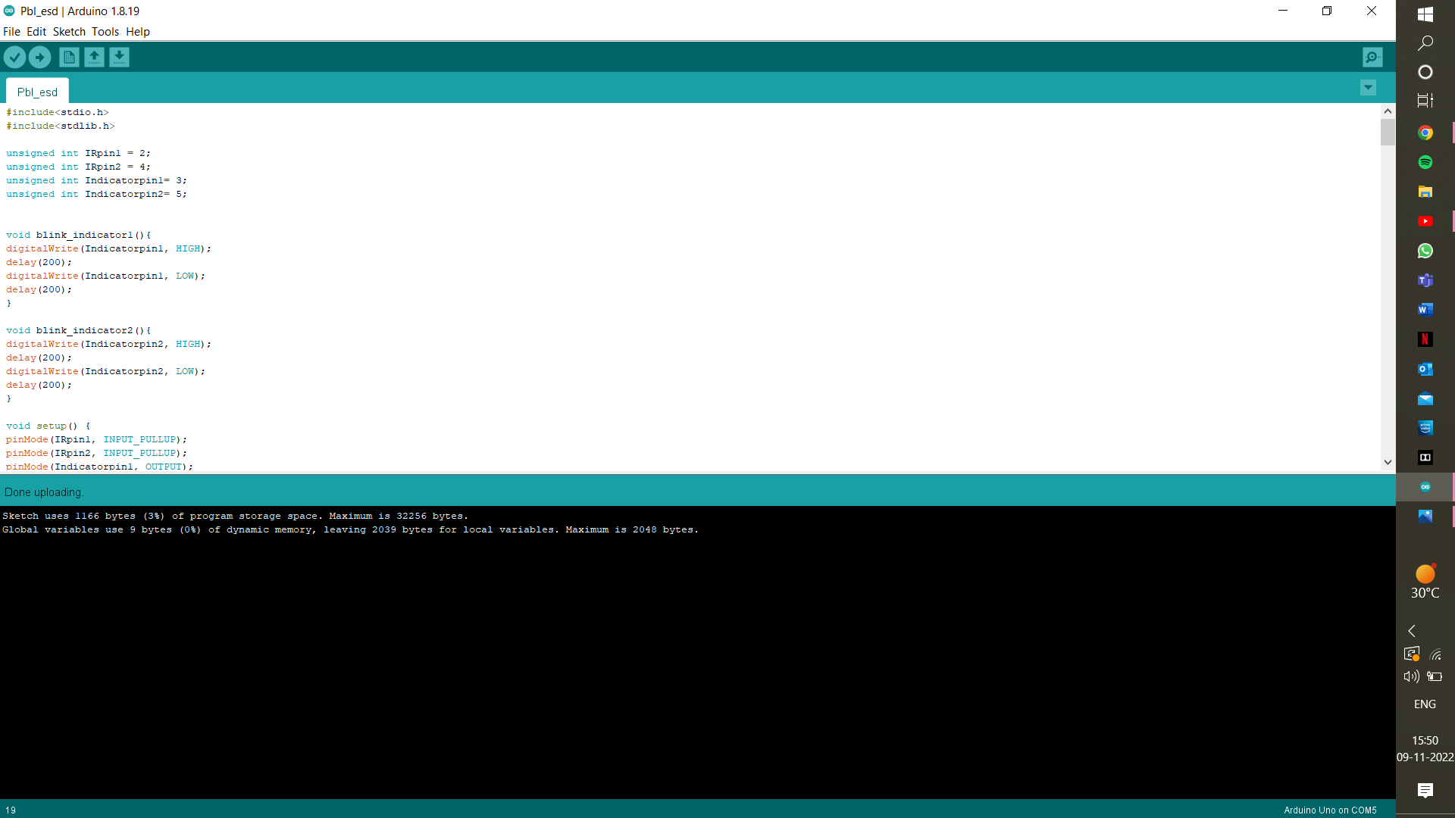

**Fig3**- Code on MATLAB

**Result**

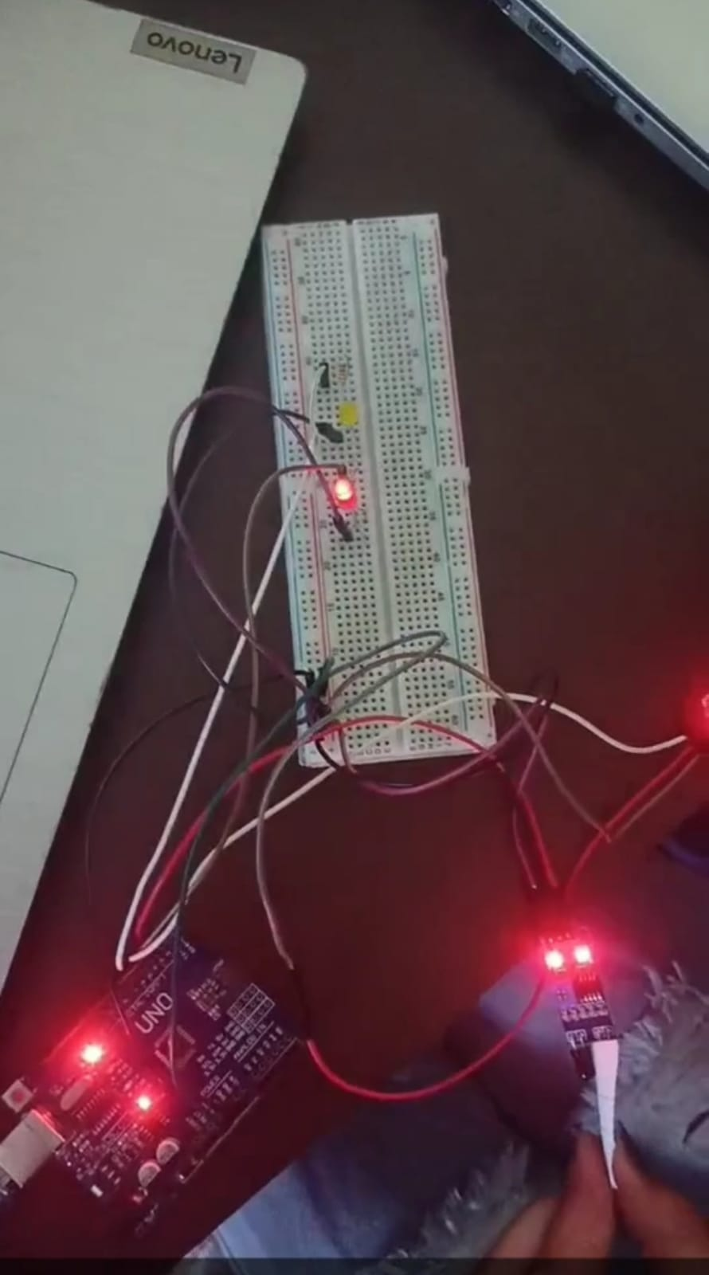

**Fig4-** When there is an obstacle between IR Sensor Red LED Glows

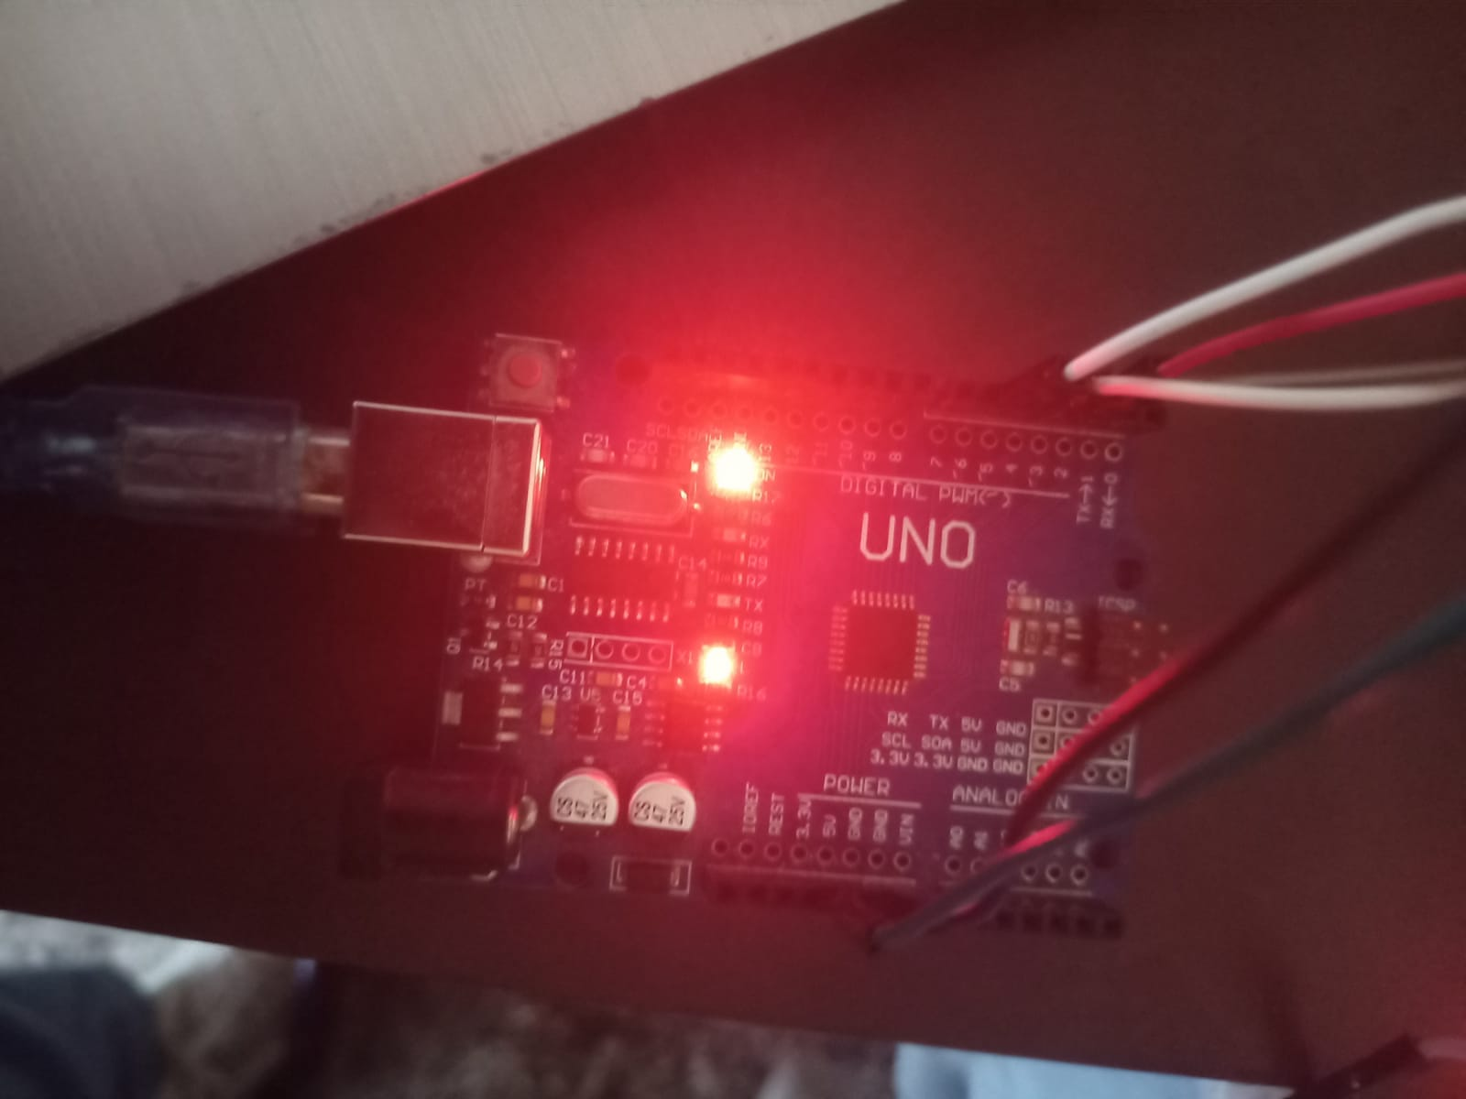

**Fig5-** Arduino UNO

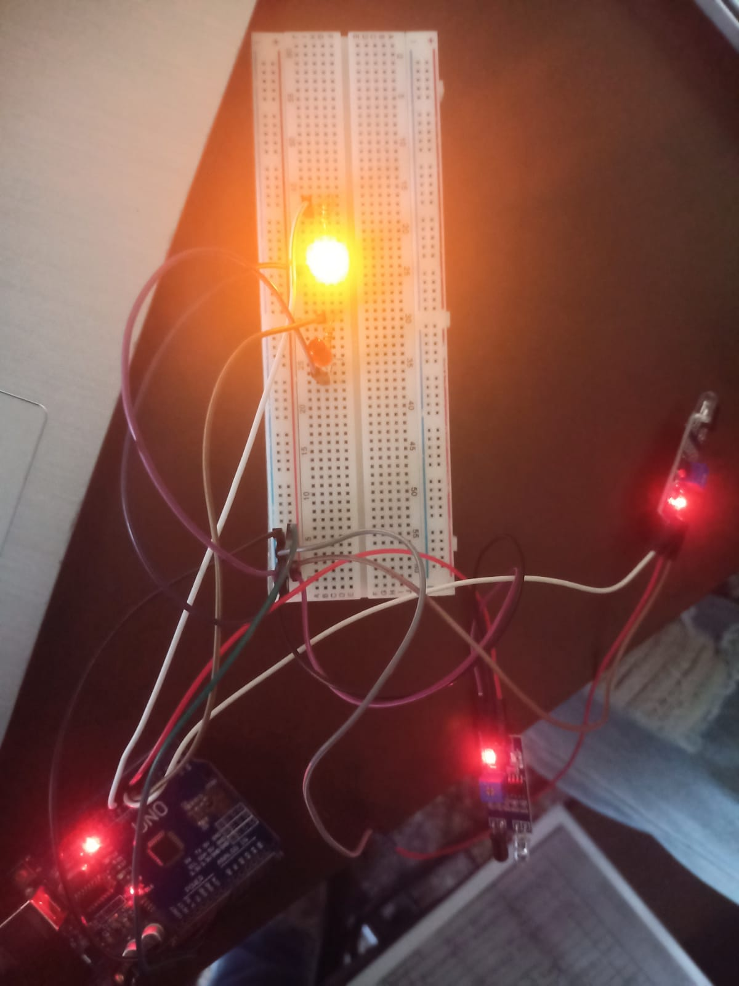

**Fig6-** IR Sensors interfacing Arduino UNO

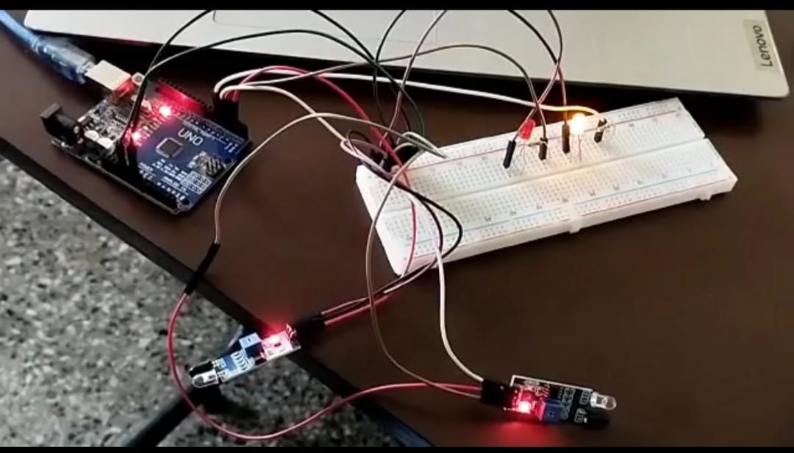

**Fig7-** No obstacle between IR Sensor

**Conclusion**

Hence, In this Project-Based Learning, on the topic- ‘Arduino-based optical proximity sensor using 2 IR LEDs’, all the concepts of Arduino hardware and Arduino UNO along with the programming and hardware connections, all the components to be used in such projects, were understood, the understanding of Arduino IDE was developed, and all the related concepts were understood well and were performed.

**Project Outcome**

The PBL project has helped us to understand the real world application. The project maps to the course outcome 6:-

CO6:- Select and use the appropriate ESP Module for real world applications.

In this project, we have used Arduino Uno development board.